# Hadoop on Azure Virtual Machines

## Hortonworks HDP Edition

This framework will automate many of the steps for creating a Hadoop cluster on Windows Azure Virtual Machines. This framework is designed to deploy Hortonworks HDP on Linux using Ambari.

This framework will automate the generation of the Azure based infrastructure, and walk through the manual steps to configure the environment. The framework is a blend of Azure CLI, bash scripts coupled with manual configuration.

The following instructions were tested on Oracle Linux 6 and CentOS 6.3/6.4. Ambari installation will fail with CentOS 6.5 at the time of this document.

This document will be used by those who prefer using Linux or Mac for deploying HDP on Windows Azure Linux VMs.

# Requirements

* Windows Azure Cross Platform Command Line Tools: <http://www.windowsazure.com/en-us/documentation/articles/xplat-cli/>
* SSH client.
* Windows Azure Subscription. Steps below assist with creating the storage account and containers.

# Overview

1. Update the hdpsetup.sh file with information about your HDP setup
2. Execute mgmtmasternode.sh
   1. Create the storage account
   2. Create the Affinity Group
   3. Create the Virtual Network
   4. Create the Management Node
   5. Create the Master Node
3. Manually configure the Management and Master nodes
   1. Attach disk (Management Node only)
   2. Set root passwords
   3. Set up passwordless SSH between the Management Node and the Master Node
   4. Set various server configurations to meet HDP requirements
   5. Update host files
4. Prepare the Master Node for provisioning
   1. Update waagent.conf (Master Node only)
   2. Run waagent –deprovision (Master Node only)
5. Create the Windows Azure Image
   1. Stop the Master Node
   2. Capture an image
6. Update hdpsetup.sh nodeImageName with the name of the captured image.
7. Execute createcusternode.sh
   1. Creates multiple Windows Azure Virtual Machines using the Master Node image
8. Install Ambari on Management Node
9. Install HDP using Ambari

# Installing HDP on Windows Azure Virtual Machines

## Preparation

#### Windows Azure Cross Platform Command Line Tools

This section provides steps for setting up a new development environment from scratch, using Windows Azure CLI.

MAC OSX Mavericks

For Mac you need to install brew. It can be installed by running the command shown below from the terminal window. Detailed instructions are here at <http://brew.sh/>

Install node by executing brew install node

Install Azure CLI by executing npm install –g azure-cli

Test that Azure CLI was installed by executing azure –v

You should see version 0.7.4 or greater

ruby -e "$(curl -fsSL https://raw.github.com/Homebrew/homebrew/go/install)"

brew update

brew doctor

brew install node

npm install -g azure-cli

azure -v

Ubuntu

Here are the instructions for install Azure CLI on Ubuntu. For a different flavor of Linux, some of the set up commands will need the corresponding changes.

## Install node.js

|  |
| --- |
| sudo apt-get install -y python-software-properties python g++ make  sudo add-apt-repository ppa:chris-lea/node.js  sudo apt-get update  sudo apt-get install nodejs |

For reference, see

<http://askubuntu.com/questions/49390/how-do-i-install-the-latest-version-of-node-js>

[Installing-Node.js-via-package-manager](https://github.com/joyent/node/wiki/Installing-Node.js-via-package-manager).

## Install CLI

|  |
| --- |
| sudo npm install -g azure-cli  # check version to ensure CLI is properly installed  azure -v # should be 0.7.4 or greater |

## Authenticate using Certificate

The development machine will use a certificate (self-signed) to authenticate against Windows Azure Management services. For details, see [How to install the Windows Azure Cross-Platform Command-Line Interface](http://www.windowsazure.com/en-us/documentation/articles/xplat-cli/#install).

|  |
| --- |
| azure account download |

A browser will pop up and prompt for login. After a successful login, you will be prompted to download and save a file with file name extension .publishsettings. This publish-settings file contains the certificate with private key, and will be used in the next step. Please note that a new management certificate is automatically created using this step. The details of this newly created certificate can also be viewed in the portal under Settings/Management Certificates section.

If the development machine is a server without a UI (user interface), the URL will be displayed on the Unix prompt along with an informational message; see below.

|  |
| --- |
| $ azure account download  info: Executing command account download  info: Launching browser to http://go.microsoft.com/fwlink/?LinkId=254432  help: Save the downloaded file, then execute the command  help: account import <file>  info: account download command OK |

Copy the URL and use and go to a different machine which does have a browser enabled. Login using a browser and download the publish-settings file. In this case, the publish-settings file will have to be copied over to the development machine before proceeding to the next step.

|  |
| --- |
| azure account import <path-to-publish-settings-file> |

If everything goes through well up to this point, you should see a hidden folder .azure in your current working directory on the development machine. This directory should contain a certificate in .pem format and other files for connecting to your Azure subscription. For example:

|  |
| --- |
| ls -la .azure  total 20  drwxrw-r-- 2 azureuser azureuser 4096 Jan 29 21:26 ./  drwxr-xr-x 8 azureuser azureuser 4096 Jan 29 21:26 ../  -rw-rw-r-- 1 azureuser azureuser 105 Jan 29 21:26 config.json  -rw------- 1 azureuser azureuser 2740 Jan 29 21:26 managementCertificate.pem  -rw------- 1 azureuser azureuser 3962 Jan 29 21:26 publishSettings.xml |

If you logon to the Windows Azure Management Portal using a browser, and navigate to Settings 🡪 Management Certificates page, you should see a certificate (with public key) already installed there. At this point the development machine is configured for interacting with the Windows Azure Subscription.

To verify that connectivity has been established, run the command shown below to list the Account/Subscription that will be accessible from this machine.

|  |
| --- |
| azure account list |

### Cluster Configuration

You will need to edit the hdpsetup.sh in a text editor. This file contains all the settings necessary to create a HDP cluster.

#### Affinity Group

Affinity Group help you deploy your compute and storage account together. You need to specify a name as well as the region where the affinity group should be created.

*#Affinty group helps you keep your storage and compute in the same region*

export affinityGroupName**=**youreasthdpag

*#Name the region where affinity group should be created.*

*#choices are valid values are "East US", "West US", "East Asia", "Southeast Asia", "North Europe", "West Europe"*

export affinityGroupLocation**=**"East US"

#### Azure Storage Account

Define the name of your storage account. This name has be globally unique as it is the public DNS for your storage account.

*#name of the storage account here your virtual machines will be stored.*

export storageAccount**=**yourhdpstorage

#### Management Node Image Name

Windows Azure provides virtual machine images that are supported by Microsoft or other vendors.

If you need to get a list of which images are available you can run the command

Azure vm image list

In this example we are select Oracle Linux 6 image

*#Name of the image you will use to create your virtual machines*

*#export imageName=b39f27a8b8c64d52b05eac6a62ebad85__Ubuntu_DAILY_BUILD-precise-12_04_3-LTS-amd64-server-20140204-en-us-30GB*

export imageName**=**c290a6b031d841e09f2da759bbabe71f__Oracle-Linux-6

#### Management Node Configuration

This will configure various settings related to management node.

*#Size of the Virtual machine. Valid sizes are extrasmall, small, medium, large, extralarge, a5, a6, a7*

export instanceSize**=extralarge**

*#Size of the data disk you want to attach to the VM you are creating. You will typically attach at least 1 disk*

export diskSizeInGB**=**5

*#Number of disks you want to attach. Small VM can have 2 disks, medium can have 4, large can have 8 and extralarge can have 8 data disks*

export numOfDisks**=**1

*#virtual machine settings. We will generate names of all the VM from these names*

export vmNamePrefix**=**yourbdhdp

export cloudServicePrefix**=**yourbdhdp

*#user name and password for the virtual machine you are creating*

export adminUserName**=**azureuser

*#Azure CLI enforces strong passwords uppercase, lower case and special characters*

export adminPassword**=**Password.1!

#### Virtual Network Setting

Virtual machines in a Hadoop cluster need to communicate with each other. We recommend putting all the virtual machines in the same virtual network. Virtual network can have one of more subnets.

You can learn more about Azure Virtual Network here <http://www.windowsazure.com/en-us/documentation/services/virtual-network/>

vnetName defines a name of the virtual network

vnetAddressSpace defines the address space for the entire virtual network. We chose IP address range 172.16.0.0/16

You can create one of more subnets in a virtual network. In this example we configured one subnet named mysubnet. The address space used by this subnet is 172.16.1.0/24

*#setting related to virtual network*

export vnetName**=**youreasthdpvnet

*#address space allows 192.168.0.0, 10.0.0.0 and 172.16.0.0 ip address ranges*

*#virtual network faq is here http://msdn.microsoft.com/en-us/library/windowsazure/dn133803.aspx*

export vnetAddressSpace**=**172.16.0.0

export vnetCidr**=**16

export subnetName**=**mysubnet

export subnetAddressSpace**=**172.16.1.0

export subnetCidr**=**24

#### Cluster Node Settings

You will need to create customized image for the nodes in your cluster. After you have created the image you will need to update the setting nodeImageName with the name of your customized image.

nodeCount is the number of nodes in your HDP cluster.

nodeSize is the size of each node. Size will depend on the type of your workload. For compute intensive workloads you may need to select a larger instance size.

*#These settings are for nodes in the HDP cluster*

*#Name of the custom image you will use to create your cluster nodes*

*#After you have create your master node image replace the value of nodeImageName wiht the image you created*

export nodeImageName**=**c290a6b031d841e09f2da759bbabe71f__Oracle-Linux-6

*#Number of nodes in your HDP cluster*

export nodeCount**=**10

*#Size of the nodes in the hadoop cluster. Valid sizes are extrasmall, small, medium, large, extralarge, a5, a6, a7*

export nodeSize**=**small

#### Hosts File

Create a host file for the nodes in the cluster. If you used address space 172.16.1.0/24 for your subnet your hosts file will look like this.

172.16.1.4 HCPNode0

172.16.1.5 HCPNode1

172.16.1.6 HCPNode2

172.16.1.7 HCPNode3

172.16.1.8 HCPNode4

172.16.1.9 HCPNode5

172.16.1.10 HCPNode6

172.16.1.11 HCPNode7

172.16.1.12 HCPNode8

172.16.1.13 HCPNode9

## Create the Infrastructure

Run the bash script create mgmtmasternode.sh

This script will use the settings defined in hdpsetup.sh to create your virtual machines. Upon successful completion this script will display detailed information about management node and master node.

#### Sample Execution Script

mgmtmasternode.sh

## Manually configure the Management and Master nodes

The Management Node is named $vmNamePrefix followed by 0, and the Master Node is named $vmNamePrefix followed by M. You will use ssh client to configure these nodes.

Use your ssh client to log into the management node and Master Node. In our example we used

ssh azureuser@yourbdhdp0.cloudapp.net

ssh azureuser@yourbdhdpM.cloudapp.net

You will be prompted for password. Enter the value of $adminPassword you defined in hdpsetup.sh file.

### Set root passwords

The first steps will be to set the root passwords on both the Management and Master Nodes. You are currently connected to the Management Node.

Elevate to root. Enter the password for the $adminUserName when prompted. Update the root password. Enter the new password when prompted.

**sudo –s**

**passwd**

Enter the following to move to the Master Node. Enter the password for the adminUserName when prompted.

**ssh <adminUserName>@<Master Node Hostname>.cloudapp.net**

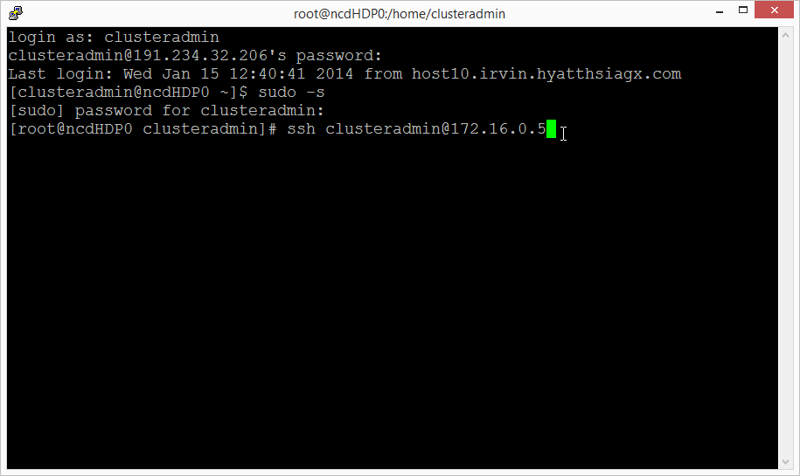

Elevate to root. Enter the password for the $adminUserName when prompted.

Update the root password. Enter the new password when prompted.

**sudo –s**

**passwd**

With both root passwords set we can now configure the nodes for the cluster.

### Management Node Configuration

Return to the Management Node. Enter the ***root*** password when prompted.

**ssh <Management Node Hostname>.cloudapp.net**

#### Update Kernel-Header

If you are using the gallery image “Oracle Linux 6.4.0.0.0”, the following steps must be executed for a successful installation of HDP.

Update the yum conf file. Comment out the line “exclude=kernel-uek-headers”

**vi /etc/yum.conf**

**# exclude=kernel-uek-headers**

Update kernel headers.

**yum install kernel-headers**

#### Mount Disks

The disks will be mounted based on a startup script.

Install perl-CPAN and open the perl shell, typing “yes” when prompted.

**yum -y install perl-CPAN**

**perl -MCPAN -e shell**

Run the following commands in the perl shell.

**install List::MoreUtils**

**install IPC::System::Simple**

**install Time::Format**

**quit**

If you are using the gallery image “Oracle Linux 6.4.0.0.0” install wget.

**yum install wget**

Copy the st.pl script to master node. You can use scp to copy this file as shown below.

scp st.pl [azureuser@management_node_hostnae.cloudapp.net:st.pl](mailto:azureuser@management_node_hostnae.cloudapp.net:st.pl)

**mkdir scripts**

**mv st.pl scripts/st.pl**

**chmod 755 scripts/st.pl**

Open crontab to add the startup script command.

**vi /etc/crontab**

Add the following line to the end of the file. Type i to enter insert mode:

**@reboot root perl /root/scripts/st.pl**

Press esc to exit insert mode. Type :wq and press enter to save and close the file.

#### Set up passwordless SSH between the Management Node and the Master Node

In the Management Node generate the key.

**ssh-keygen**

Accept the default file location when prompted (press enter). Press enter to create the key without a passphrase. The public key is stored in .ssh/id_rsa.pub, and the private key is id_rsa. You will use the private key later during the HDP installation. At this time you will copy the public key to the Master Node to enable passwordless ssh.

Copy the key to the Master node and Management Node (self-referencing), enter the root password when prompted.

**ssh-copy-id -i /root/.ssh/id_rsa.pub root@<Master Node Hostname>.cloudapp.net**

**ssh-copy-id -i /root/.ssh/id_rsa.pub root@<Management Node Hostname>.cloudapp.net**

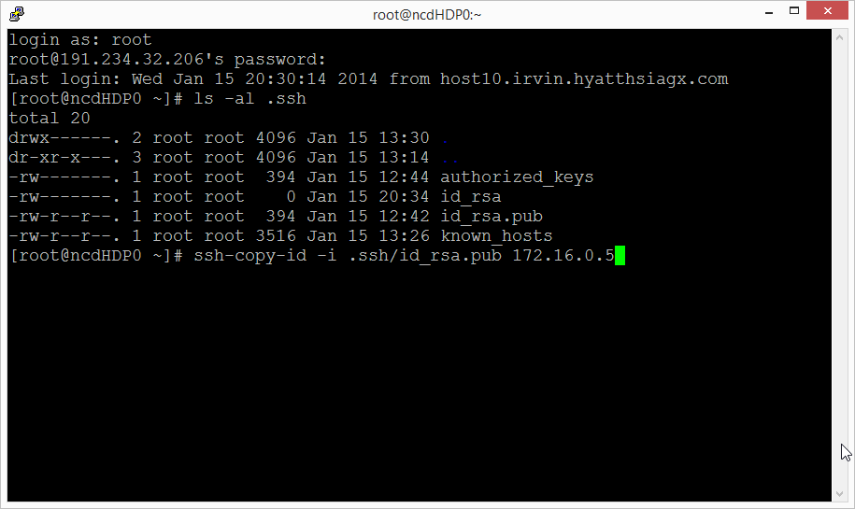

To test the keys were set up correctly, type the following and validate that you are not prompted for a password.

**ssh <Management Node Hostname>.cloudapp.net**

**ssh <Master Node Hostname>.cloudapp.net**

#### Update Host Files

Open the hosts files for editing

**vi /etc/hosts**

Paste the host data at the end of the file. Press esc to exit insert mode. Type :wq and press enter to save and close the file.

#### Update Server Configuration Settings

Type the following commands to configure the server settings for HDP prerequisites.

**#disable iptables**

**chkconfig iptables off**

**/etc/init.d/iptables stop**

**setenforce 0**

**#start ntp service**

**chkconfig ntpd on**

**ntpdate pool.ntp.org**

### Master Node Configuration

Return to the Master Node. You should not be prompted for a password.

**ssh <Master Node Hostname>.cloudapp.net**

#### Update Kernel-Header

If you are using the gallery image “Oracle Linux 6.4.0.0.0”, the following steps must be executed for a successful installation of HDP.

Update the yum conf file. Comment out the line “exclude=kernel-uek-headers”

**vi /etc/yum.conf**

**# exclude=kernel-uek-headers**

Update kernel headers.

**yum install kernel-headers**

#### Mount Disks

The disks will be mounted based on a startup script named st.pl.

Install perl-CPAN and open the perl shell, typing “yes” when prompted.

**yum -y install perl-CPAN**

**perl -MCPAN -e shell**

From the perl shell, install the necessary perl modules.

**install List::MoreUtils**

**install IPC::System::Simple**

**install Time::Format**

**quit**

If you are using the gallery image “Oracle Linux 6.4.0.0.0” install wget.

**yum install wget**

Copy the st.pl script to master node. You can use scp to copy this file as shown below.

scp st.pl [azureuser@management_node_hostnae.cloudapp.net:st.pl](mailto:azureuser@management_node_hostnae.cloudapp.net:st.pl)

**mkdir scripts**

**mv st.pl scripts/st.pl**

**chmod 755 scripts/st.pl**

Update crontab to add the startup script.

**vi /etc/crontab**

Add the following line to the end of the file.

**@reboot root perl /root/scripts/st.pl**

#### Update Host Files

Open the hosts files for editing.

**vi /etc/hosts**

Paste the host data at the end of the file. Press esc to exit insert mode. Type :wq and press enter to save and close the file.

#### Update Server Configuration Settings

Configure the server settings for HDP prerequisites.

**#disable iptables**

**chkconfig iptables off**

**/etc/init.d/iptables stop**

**setenforce 0**

**#start ntp service**

**chkconfig ntpd on**

**ntpdate pool.ntp.org**

#### Windows Azure Linux Agent

Set up the virtual machine for provisioning as an image. Open the waagent.conf file.

**vi /etc/waagent.conf**

Change the following settings:

**Provisioning.DeleteRootPassword=n**

**Provisioning.RegenerateSshHostKeyPair=n**

Press esc to exit insert mode. Type :wq and press enter to save and close the file.

Run the Windows Azure Linux Agent.

**waagent –deprovision**

Return to the Management Node.

**ssh <Management Node Hostname>.cloudapp.net**

## Capture the Master Image

Open the Windows Azure Management Portal and navigate to the dashboard of the Master Node virtual machine. Shut down the machine. After the machine is stopped, click Capture to create an image.

Update the hdpsetup.sh file nodeImageName with the value of image you created.

## Create the Cluster

Run the bash script createclusternodes.sh

#### Sample Execution Script

Createclusternode.sh

At the completion of the script, you will have a set of virtual machines to install Hadoop.

To test the virtual machines were generated correctly, open a PuTTY connection from the Management node and connect to a few of the machines to verify the host name and to verify passwordless ssh is working:

**ssh <Machine Hostname>.cloudapp.net**

**hostname**

## Install Ambari

Open an SSH session in PuTTY to the Management Node.

Download and install Ambari:

**wget http://public-repo-1.hortonworks.com/ambari/centos6/1.x/updates/1.4.2.104/ambari.repo**

**cp ambari.repo /etc/yum.repos.d**

**yum install ambari-server**

After the installation has completed, run the setup:

**ambari-server setup**

## Restart VMs

Restart all VMs to ensure the disks are mounted. Using PowerShell:

$imageNamePrefix = "HDPNode"

Get-AzureVM | where {$_.Name -like "*$imageNamePrefix*"} | Restart-AzureVM

After the management node is restarted, verify Ambari is started. Connect to the Management Node in PuTTY and execute the following command:

**ambari-server start**

## Install HDP

Open the browser and navigate to http://<Management Node Hostname>:8080

When prompted, log in as admin with password admin.

In general, follow the prompts to install. The only tricky part I would point out is in the install screen to input hosts and the key. You will paste the private key from the Management Node:

**cat .ssh/id_rsa**

Highlight the full key and press enter to copy to the clipboard. You will then paste this in the web interface.